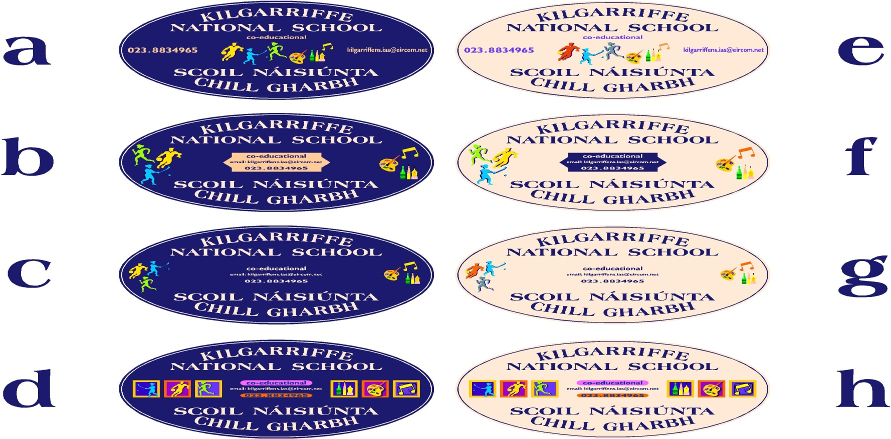

Kilgarriffe National School

Old Timoleague Road, Desert, Clonakilty, Co, Cork

Roll No: 10499U Tel: 023 8834965/083 0658096

Email: [kilgarriffens.office@gmail.com](mailto:kilgarriffens.office@gmail.com) Web: [www.kilgarriffens.ie](http://www.kilgarriffens.ie)

**Internet Acceptable Use Policy**

**The aim of this Acceptable Use Policy is to ensure that pupils will benefit from learning opportunities offered by the school’s Internet resources in a safe and effective manner. It is envisaged that school management will revise the AUP annually. Before signing enrollment forms, the AUP should be read carefully to indicate that the conditions of use are accepted and understood.**

**School’s Strategy**

**The school will employ a number of strategies in order to maximize learning opportunities and reduce risks associated with the Internet. These strategies are as follows:**

* **Internet sessions will always be supervised by a teacher.**
* **Filtering software and/or equivalent systems will be used in order to minimise the risk of exposure to inappropriate material.**
* **The school will regularly monitor pupils’ Internet usage.**
* **Students and teachers will be provided with training in the area of Internet safety.**
* **Uploading and downloading of non-approved software will not be permitted.**
* **Students will observe good “netiquette” (ie. etiquette on the Internet) at all times and will not undertake any actions that may bring the school into disrepute.**

**Internet Use**

* **Students will use the Internet for educational purposes only.**
* **Students will be familiar with copyright issues relating to online learning.**
* **Students will never disclose or publicise personal information.**
* **Students will be aware that any usage, including distributing or receiving information, school-related or personal, may be monitored for unusual activity, security and/or network management reasons.**
* **Students will not visit Internet sites that contain obscene, illegal, hateful or otherwise objectionable materials.**

**Seesaw**

**Seesaw is an online learning platform used throughout the school to facilitate remote learning when needed. It is also used as a digital portfolio to keep a record of student work.**

* **All student posts and comments are pre-approved by the teacher.**

**School Website/Facebook**

* **The publication of student work will be co-ordinated by a teacher.**
* **On enrollment, parents give consent/ or not to the use of photos and videos of their child.**
* **The names of children will not be published alongside their image.**

**Aladdin**

**Aladdin is an online administration tool widely used by schools. It is a secure platform for student information such as attendance and reports. Access via secure codes are given to parents on enrollment. Parents can access their account via an app on their phone.**

**Legislation**  
**Information on the following legislation relating to use of the Internet is available online, which teachers, students and parents should familiarize themselves with:**

* **Data Protection Acts 1988 & 2003**
* **Child Trafficking and Pornography Act 1998**
* **Interception Act 1993**
* **Video Recordings Act 1989**
* **Irish Data Protection Act 2018**
* **EU GDPR regulation 2018**

**For further information on GDPR regulations and data protection see the school’s data protection policy.**

**Support Structures**

**From time to time the school will host an internet safety information presentation for students and/or parents. Cyber Safety is also taught within the SPHE curriculum e.g. Stay Safe Programme and Webwise materials.**

**Sanctions**

**Misuse of the Internet may result in disciplinary action, withdrawal of access and, in extreme cases, suspension or expulsion. The school also reserves the right to report any illegal activities to the appropriate authorities.**

**Permission Form/ Consent**

**Consent for Internet Acceptable Use Policy is now included as part of the enrollment forms.**

**Ratified by Board of Management**

**Chairperson: ____________________________ Date: ___________________**